## **Centos6.5 安装 MySql5.7（yum方式）**

**yum -y install gcc-c++ ncurses-devel cmake make perl gcc autoconf automake zlib libxml libgcrypt libtool bison**  **yum-utils**

1.检查系统是否已存在旧版mysql，并卸载。

# yum list installed | grep mysql

mysql-libs.x86_64 5.1.71-1.el6 @anaconda-CentOS-201311272149.x86_64/6.5

# yum -y remove mysql-libs.x86_64

mysql5.7安装包可以去官网下载 https://dev.mysql.com/downloads/repo/yum/

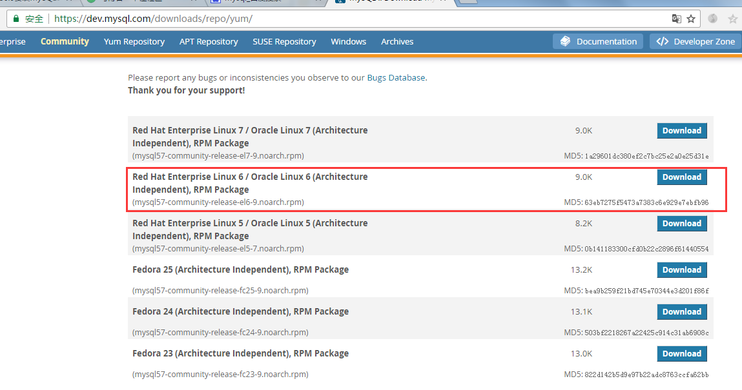

下载：

wget <https://dev.mysql.com/get/mysql80-community-release-el6-1.noarch.rpm>

安装repo仓库：

sudo rpm -Uvh mysql80-community-release-el6-1.noarch.rpm

查看版本：

yum repolist all | grep mysql

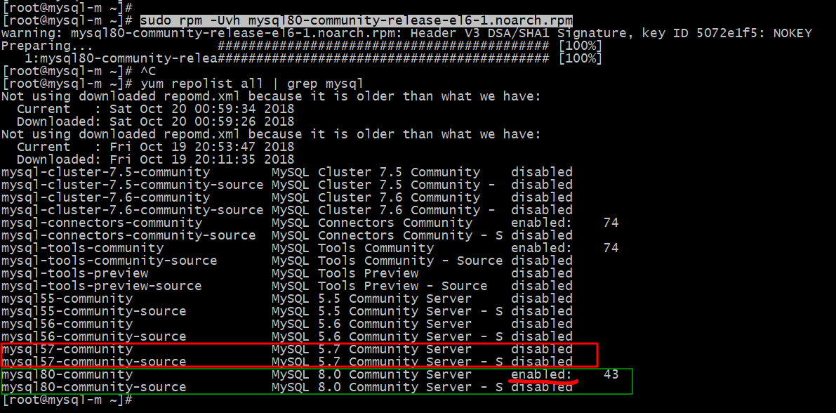

**yum-config-manager: command not found**

这个是因为系统默认没有安装这个命令，这个命令在yum-utils 包里，可以通过命令：

yum -y install yum-utils 安装就可以了。

shell>sudo yum-config-manager --disable mysql80-community

shell> sudo yum-config-manager --enable mysql57-community

安装：

sudo yum install mysql-community-server

启动：

sudo service mysqld start

安装mysql5.7，遇到选项输入y就行了。或者安装的时候添加 -y 参数

# yum install mysql57-community-release-el6-8.noarch.rpm

# ls /etc/yum.repos.d

CentOS-Base.repo CentOS-Media.repo mysql-community.repo

CentOS-Debuginfo.repo CentOS-Vault.repo mysql-community-source.repo

# yum install mysql-community-server

网络状况不好时需要耐心等待一会儿。

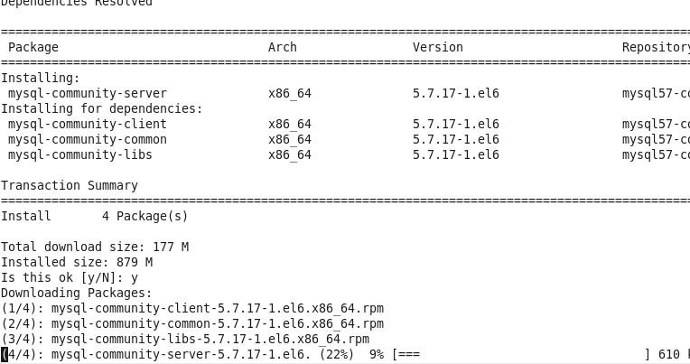

安装完成，启动mysql

# service mysqld start

Initializing MySQL database: [ OK ]

Installing validate password plugin: [ OK ]

Starting mysqld: [ OK ]

 查看mysql 密码

# grep "password" /var/log/mysqld.log

2017-03-16T14:39:00.743966Z 1 [Note] A temporary password is generated for root@localhost: F7u?yhf,#LR6

2017-03-16T14:39:06.760164Z 0 [Note] Execution of init_file '/var/lib/mysql/install-validate-password-plugin.XkuhjP.sql' started.

2017-03-16T14:39:06.809413Z 0 [Note] Execution of init_file '/var/lib/mysql/install-validate-password-plugin.XkuhjP.sql' ended.

2017-03-16T14:39:08.625174Z 0 [Note] Shutting down plugin 'sha256_password'

2017-03-16T14:39:08.625190Z 0 [Note] Shutting down plugin 'mysql_native_password'

2017-03-16T14:39:13.324745Z 3 [Note] Access denied for user 'UNKNOWN_MYSQL_USER'@'localhost' (using password: NO)

修改密码 无密码进入mysql控制台

# vim /etc/my.cnf

在/etc/my.cnf [mysqld] 后添加

skip-grant-tables=1

重启 msyql

# service mysqld restartStopping mysqld: [ OK ]

Starting mysqld: [ OK ]

进入mysql控制台修改密码

# mysql -uroot

Welcome to the MySQL monitor. Commands end with ; or \g.

Your MySQL connection id is 5

Server version: 5.7.17 MySQL Community Server (GPL)

Copyright (c) 2000, 2016, Oracle and/or its affiliates. All rights reserved.

Oracle is a registered trademark of Oracle Corporation and/or its

affiliates. Other names may be trademarks of their respective

owners.

Type 'help;' or '\h' for help. Type '\c' to clear the current input statement.

mysql>

切换至mysql数据库

mysql> use mysql;

Reading table information for completion of table and column names

You can turn off this feature to get a quicker startup with -A

Database changed

查看user表中的信息

mysql> select user,host,authentication_string from user;

+-----------+-----------+-------------------------------------------+| user | host | authentication_string |

+-----------+-----------+-------------------------------------------+| root | localhost | *39820588410CB0B7DDA4AD6595C19A92C7B52B52 || mysql.sys | localhost | *THISISNOTAVALIDPASSWORDTHATCANBEUSEDHERE |

+-----------+-----------+-------------------------------------------+

修改root[@localhost](https://my.oschina.net/u/570656" \t "https://my.oschina.net/unteacher/blog/_blank) 密码

mysql> update user set authentication_string=password('123456') where user='root' and host='localhost';

Query OK, 1 row affected, 1 warning (0.05 sec)

Rows matched: 1 Changed: 1 Warnings: 1

 查看并退出控制台

mysql> select user,host,authentication_string from user;

+-----------+-----------+-------------------------------------------+| user | host | authentication_string |

+-----------+-----------+-------------------------------------------+| root | localhost | *6BB4837EB74329105EE4568DDA7DC67ED2CA2AD9 || mysql.sys | localhost | *THISISNOTAVALIDPASSWORDTHATCANBEUSEDHERE |

+-----------+-----------+-------------------------------------------+2 rows in set (0.01 sec)

mysql> exit;

Bye

用新密码登录

# mysql -uroot -p

Enter password:

输入密码，成功登录

# mysql -uroot -p

Enter password:

Welcome to the MySQL monitor. Commands end with ; or \g.

Your MySQL connection id is 6

Server version: 5.7.17 MySQL Community Server (GPL)

Copyright (c) 2000, 2016, Oracle and/or its affiliates. All rights reserved.

Oracle is a registered trademark of Oracle Corporation and/or its

affiliates. Other names may be trademarks of their respective

owners.

Type 'help;' or '\h' for help. Type '\c' to clear the current input statement.

mysql>

对安全无要求的测试场景可以设置 skip-grant-tables=1，不然则注释skip-grant-tables

授予远程访问权限

mysql> GRANT ALL PRIVILEGES ON *.* TO 'root'@'%' IDENTIFIED BY '123456' WITH GRANT OPTION;

ERROR 1290 (HY000): The MySQL server is running with the --skip-grant-tables option so it cannot execute this statement

出现以上问题可以刷新一下再执行

mysql> flush privileges;

Query OK, 0 rows affected (0.06 sec)

mysql> GRANT ALL PRIVILEGES ON *.* TO 'root'@'%' IDENTIFIED BY '123456' WITH GRANT OPTION;

Query OK, 0 rows affected, 1 warning (0.00 sec)

查看新添加的权限

mysql> select user,host,authentication_string from user;

+-----------+-----------+-------------------------------------------+| user | host | authentication_string |

+-----------+-----------+-------------------------------------------+| root | localhost | *6BB4837EB74329105EE4568DDA7DC67ED2CA2AD9 || mysql.sys | localhost | *THISISNOTAVALIDPASSWORDTHATCANBEUSEDHERE || root | % | *6BB4837EB74329105EE4568DDA7DC67ED2CA2AD9 |

+-----------+-----------+-------------------------------------------+3 rows in set (0.01 sec)

## 关于安装centOS6.9安装mysql5.7遇到的一些报错

1. 首先要看一下你的系统型号（现在基本都不用看了，以防万一）

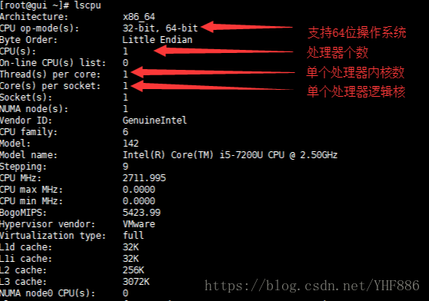

2.今天安装的时候遇到了奇怪的报错

我先下载了mysql

wget http://repo.mysql.com/mysql57-community-release-el7-8.noarch.rpm

然后使用yum安装

yum -y install mysql57-community-release-el7-8.noarch.rpm

接下来安装服务端

yum -y install mysql-server

以前在centOS7上一点问题都不会出现，但是接着报错

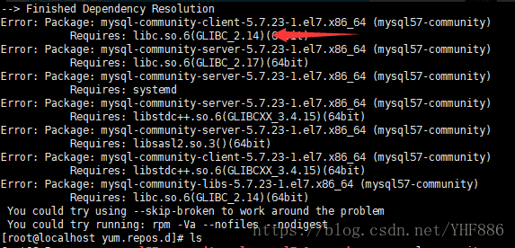

出现上面的报错提示需要安装 GLIBC2.14 这个版本，然后就各种百度

其实就是你的系统与安装的软件版本不对

3.卸载已安装的mysql

停掉你的mysql服务

systemctl stop mysqld.service #centOS7

service mysqld stop #centOS6

删掉或备份你的mysql数据库（我选择的是删除，如果数据比较重要记得一定要备份）

rm -rf /etc/my.cnf

rm -rf /var/lib/mysql

接着卸载已经安装的mysql的rpm包

yum list installed | grep mysql

rpm -qa |grep -i mysql #查找已安装的服务

mysql-community-client.x86_64 5.7.17-1.el7 installed

mysql-community-common.x86_64 5.7.17-1.el7 installed

mysql-community-devel.x86_64 5.7.17-1.el7 installed

mysql-community-embedded.x86_64 5.7.17-1.el7 installed

mysql-community-embedded-compat.x86_64 5.7.17-1.el7 installed

mysql-community-embedded-devel.x86_64 5.7.17-1.el7 installed

mysql-community-libs.x86_64 5.7.17-1.el7 installed

mysql-community-libs-compat.x86_64 5.7.17-1.el7 installed

mysql-community-minimal-debuginfo.x86_64 5.7.17-1.el7 installed

mysql-community-server.x86_64 5.7.17-1.el7 installed

mysql-community-test.x86_64 5.7.17-1.el7 installed

mysql57-community-release.noarch el7-8 installed

**yum remove mysql* #卸载服务（卸载的时候有会遇到一些问题）**

**rpm -ev 完整的包名 #建议使用这个卸载**

**yum remove 完整包名 #有一些mysql是rpm方式安装的会很难卸载 使用这个就可以**

PS：卸载不了的rpm包不要着急，可以清理内存，也可以去喝杯咖啡，等内存自动释放了，再次卸载。

1. centOS6.9安装mysql5.7

**首先下载 “正确的”“正确的”“正确的” mysql版本（重要的事情说三遍）**

去mysql的yum官网 http://repo.mysql.com/

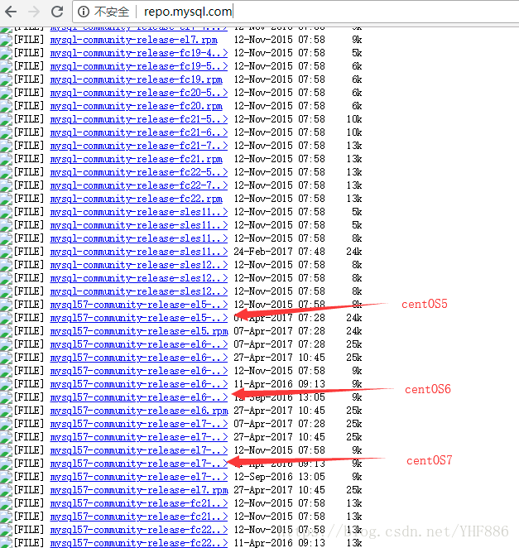

这里提供了一个与系统相匹配的的yum源，否则会报错 libc.so.6 GLIBC2.14 （一定使用官方的源否则后果自负）

接下来下载安装

**wget http://repo.mysql.com/mysql57-community-release-el6-9.noarch.rpm**

**yum -y install mysql57-community-release-el6-9.noarch.rpm #安装就会提供相对应的yum源**

**yum -y install mysql-server #会用最新的源**

**service mysqld start #初始化服务**

**ps -C mysqld #查看进程**

**netstat -utnlp | grep mysqld #查看端口**

**grep password /var/log/mysqld.log #查找初始化的密码**

**mysql -hlocalhost -uroot -p'初始化密码' #登录本地服务**

**mysql>alter user root@"localhost" identified by "新密码（尽量复杂）"; #搞定**

安装完注意端口（是否开放根据自己需要）

**[root@localhost ~]# iptables -I INPUT -p tcp -m state --state NEW -m tcp --dport 3306 -j ACCEPT //centOS6版本的端口放行**

**[root@localhost ~]# firewall-cmd --permanent --zone=public --add-port=3306/tcp**

**success //centOS7 版本的端口放行**

**[root@localhost ~]# firewall-cmd --reload**

**success //刷新规则**

## 解决 Requires: libc.so.6(GLIBC_2.14)(64bit)

在 Centos 6 上安装一个软件，报 Requires: libc.so.6(GLIBC_2.14)(64bit)，使用命令 strings /lib64/libc.so.6 | grep GLIBC，查看支持的 gblic 版本

[root@kvm supdev]# strings /lib64/libc.so.6 | grep GLIBC

GLIBC_2.2.5

GLIBC_2.2.6

GLIBC_2.3

GLIBC_2.3.2

GLIBC_2.3.3

GLIBC_2.3.4

GLIBC_2.4

GLIBC_2.5

GLIBC_2.6

GLIBC_2.7

GLIBC_2.8

GLIBC_2.9

GLIBC_2.10

GLIBC_2.11

GLIBC_2.12

GLIBC_PRIVATE

下载 glibc-2.14.tar.gz

**wget http://ftp.gnu.org/gnu/glibc/glibc-2.14.tar.gz**

**tar xf glibc-2.14.tar.gz**

**cd glibc-2.14**

**mkdir build**

**cd build**

**../configure --prefix=/opt/glibc-2.14 --disable-profile --enable-add-ons --with-headers=/usr/include --with-binutils=/usr/bin**

**make**

**make install**

编译好后，再看看

[root@kvm supdev]# strings /lib64/libc.so.6 | grep GLIBC

GLIBC_2.2.5

GLIBC_2.2.6

GLIBC_2.3

GLIBC_2.3.2

GLIBC_2.3.3

GLIBC_2.3.4

GLIBC_2.4

GLIBC_2.5

GLIBC_2.6

GLIBC_2.7

GLIBC_2.8

GLIBC_2.9

GLIBC_2.10

GLIBC_2.11

GLIBC_2.12

GLIBC_2.14

GLIBC_PRIVATE